Record of Processing (RoP) Guidance

Introduction to a controllers responsibility in completing a record of processing
As a Controller you determine the purpose and means of the processing (article 4(7)) and are responsible for ensuring the confidentiality and integrity (article 5(f)) of data and to ensure technical and organisational measures are in place (article 32). This means you are also responsible for assessing the risks if necessary, via a Data Protection Impact Assessment (article 35) and if so, will need to involve your processors and DPO to support this. You are also responsible for maintaining a RoP (article 30). DPE’s methodology for completing the RoP and assessing risks to support compliance have been incorporated within the RoP Manager: DPE Methodology for completing a DPIA within the RoP

What does the RoP look like?
The easiest way to think of the RoP is that these are the life cycle of a process from start to finish with the process being mapped out in the RoP. Within each process and step, data will have different values. There are different risks to data as it moves through an organisation from collection, processing, use, disclosure, retention, and destruction. The RoP captures the full life cycle of a process and risks associated. The RoP has been designed to incorporate all areas of your organisation where an RoP is required, this being:

- Commercial and Community
- Extra-curricular
- Facilities
- Finance
- Human Resources
- Management of the School
- Pupil Management
- Teaching and Learning
- Other

WIthin each area you will have specific processing that takes place, for example, student admissions, payroll and recruitment. As an example, if you were to look at the administrative process for recruitment and the description of the process for: Processing and shortlisting of candidates, the life cycle of the process (data flow) would represent the steps you would take:
Step 1: Requesting Information re Shortlisted candidates;
Step 2: Processing of Shortlisted Candidates;
Step 3: Information Sharing & Information Security and;
Step 4: Requesting Professional References

Each of these steps (data flows) within a process would have risks associated with that step, for example: loss of data, and each step would have a risk response as to how the organisation has mitigated the risk and how you would handle the risk i.e. tolerate or treat. Each process would also have a owner (ie. senior administrator).

The Record of Processing (RoP) Manager should include information about data processing, including data categories, the group of data subjects, the purpose of the processing, data retention periods (where possible), lawful basis for processing and the data recipients. This must be completely made available to authorities upon request (https://gdpr-info.eu/issues/records-of-processing-activities/). You would be expected to add your own suppliers, hardware and third party lists in the RoP as well. Don’t worry, we will support you with this process!

Completed correctly the RoP will mean you can then demonstrate, not only how you’ve managed risks but will be able to identify the what, how and when with the processing, with different systems and security controls in place, as the data flows from one step to another.

How is DPEs Record of Processing Manager different and how can it be used to support your organisation?
DPE’s RoP has been designed to have all of the information in one place and to be able to pull data out to support risk management, data minimisation, privacy, school improvement and demonstrates your commitment with GDPR compliance. For example:

- Adopting a privacy by design approach (article 25)
- Incorporate risks and for the most part allow for DPIAs (risk assessments) to be completed within the Manager (article 35);
- Identify problems early (article 25)
- Find simpler less costly solutions
- Reduce costs by minimisation i.e. utilising electronic systems (article 5 b)
- Produce more straightforward processes
- Improve transparency (article 12,13,14)
- It will allow you to pull data out, allowing the data to be used for decision making and communications by:
Generating reports, for example : privacy statements (articles 13-14) and DPIAs (article 35) ;
Generate process flows to allow visual representation of a process.

Please note: some of the above is still under development

Generating a retention schedule from the RoP
This can be done by going to Knowledge Bank’s main dashboard, and selectionMy Activities / select Generated Reports / the select Retnetion Schedule, this will provide details includng: :

Required length of retention
Retention start
Retention justification
Actions required at the end of retention period ie secure deletion

Generating a risk report from the RoP
This is possible by accessing your RoP Manager on Knowledge Bank, selecting the relevant RoP
and then selecting process a risk report. This will provide you with a detailed report, noting:

The data subject categories involved in the process
Source of the personal data
Categories of recipients of this data
Data classification

Funamental Principles
- The lawful basis for processing
- Assessment of controls protecting the data subject’s rights
- Retention duration
- Retentin justification

Data Risks and Mitigation
- Likelihood
- Type of data risk
- Level of the data subjects identificatin
- Potential impacts
- Severity of potential impact
- Mitigating action
- Details of mitigation

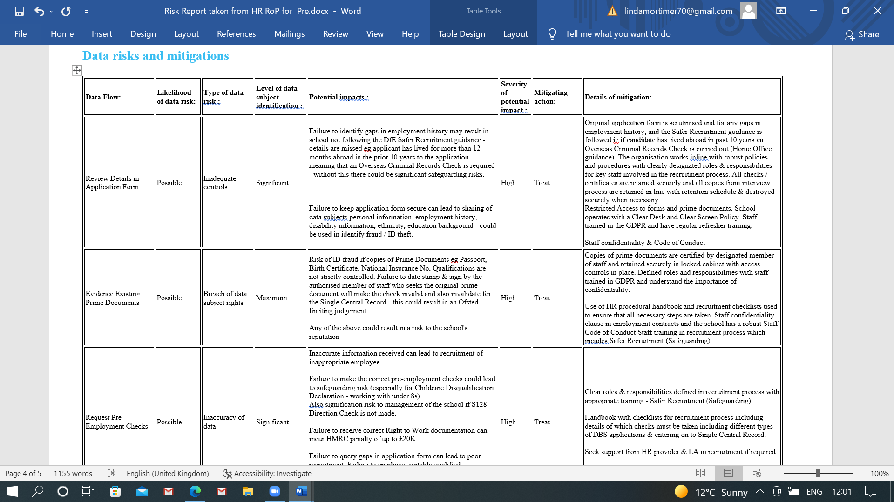

What have DPE been doing to support you
DPE recognise that there is a considerable time burden being placed on schools to complete the RoP in full. In addition, many of the processes will be the same or similar across the sector. For this reason DPE has been working with a selection of schools and Trusts to determine the key processes and to start the process for you. This will result in considerable time savings for your organisation and the creation of sector specific and standard RoP.
How is this being completed?
DPE have been:
- Working with schools remotely to increase understanding and maintaining of the RoP
- Working with schools to start the process of populating your master lists for: hardware, software and third parties;
- Updating the RoP with the top ROPs for primary, secondary schools and academies;
- Using the remote consultations to map across and increase understanding of the RoP
So what do we need to do and what’s next?
As we continue to roll out the RoP you will increasingly be involved in maintaining, updating and working with DPE to populate and take ownership of your RoPs. In addition to this, there will be further information required, for example: software; hardware and supplier information.

We really want the RoP to be used in school, not just as a tick list to say you comply with the GDPR but as a genuine product that has real benefits for you. We will work with you to complete these tasks.

An example of how to complete an RoP for the Processing and Shortlisting of Candidates

You access the RoP Manager via your school dashboard:
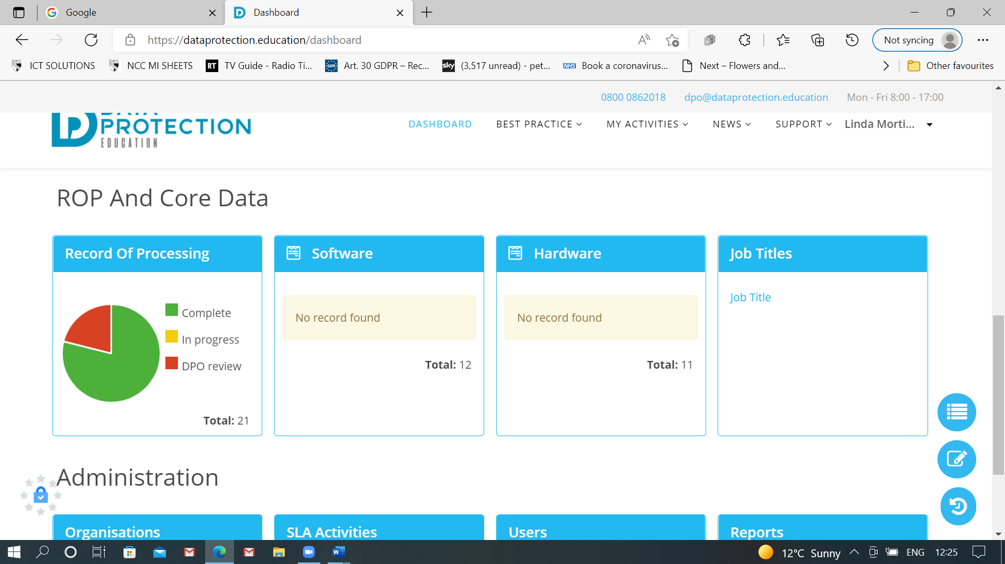

The RoP is mapped out to reflect the main areas within school:

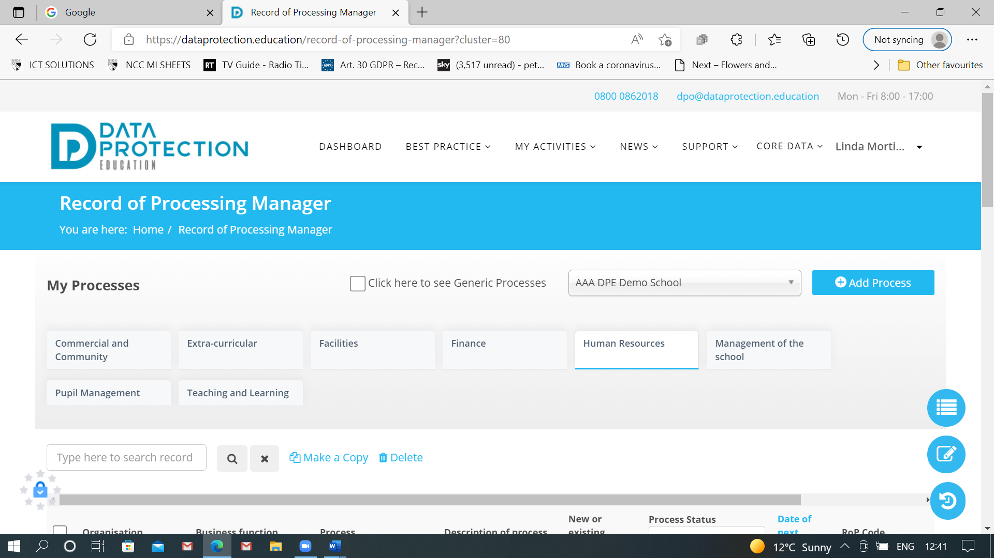
Once a heading is selected you can then see individual processes, or see what processes have been mapped out:. To copy a generic process, select the process you would like to copy and: make a copy. You will need to submit and save to view this for your school:

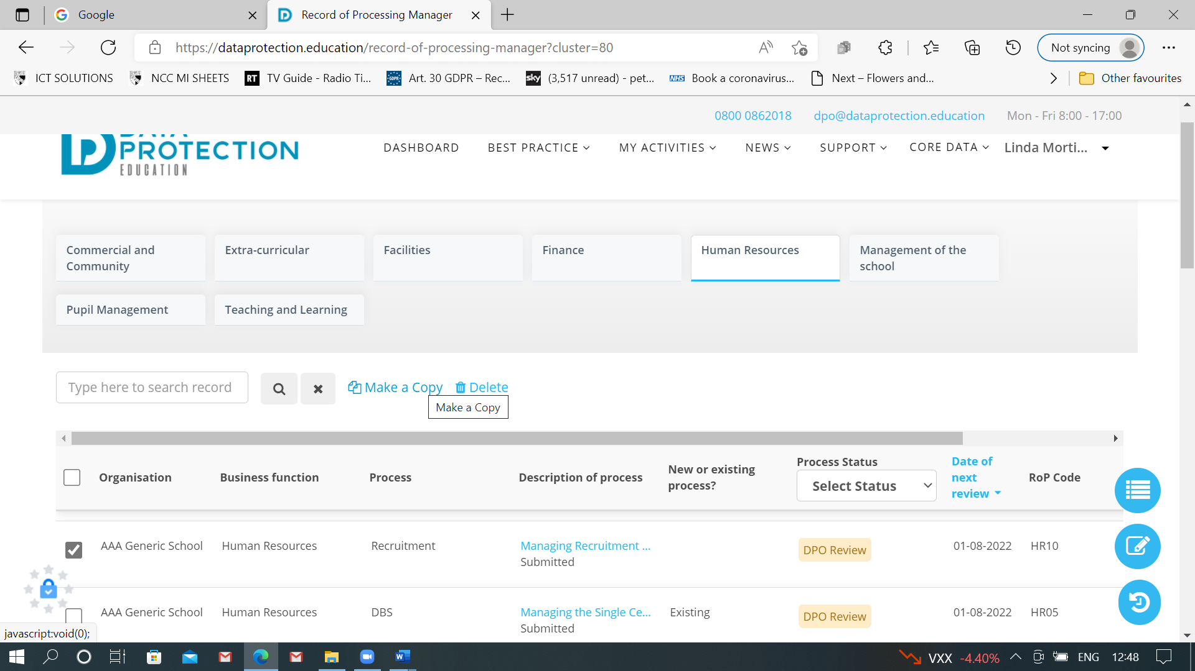

The ROP Manager has 5 Tabs that need completing and they are found to the righthand side of the screen:

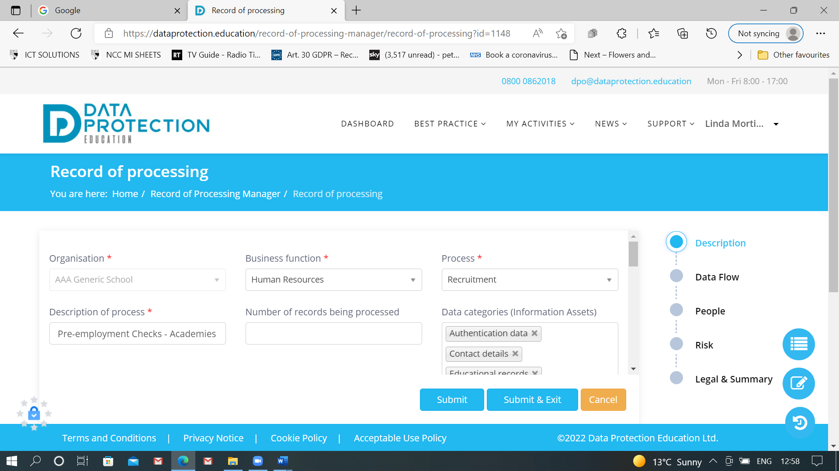

Here is an example of an RoP for processing of shortlisting of candidates:
TAB 1 - DESCRIPTION
The Organisation – you will be able to select your school name (although at the moment the RoP is showing Generic School)
The Business Function – if we are talking about recruitment the Business Function would be Human Resources
The Process – is Recruitment
Description of Process – is the Processing and Shortlisting of Candidates
Data Categories – Choose from the drop down menu and select the categories, as you can see this process covers many categories all of which are included on the candidates completed application form
Data Subject Categories – We have selected Employees, Candidates
Source of the Personal Data – who is supplying this data? Supplied by the Data Subject
Categories of Recipients – who will see this information – apart from key staff ie Headteacher, BM, Governors (who will be on the shortlisting panel), Local Authority (representative could also be on the shortlisting panel), Employees

TAB 2 – The Data Flow
We can identify 4 key steps in the life cycle of the RoP for Shortlisting of Candidates:
- Initial Processing of the Completed Application Form

- Informatio Gatering Required for Shortlisting

- Information Sharing and Information Security

- Requesting Referenced for Selected Candidates
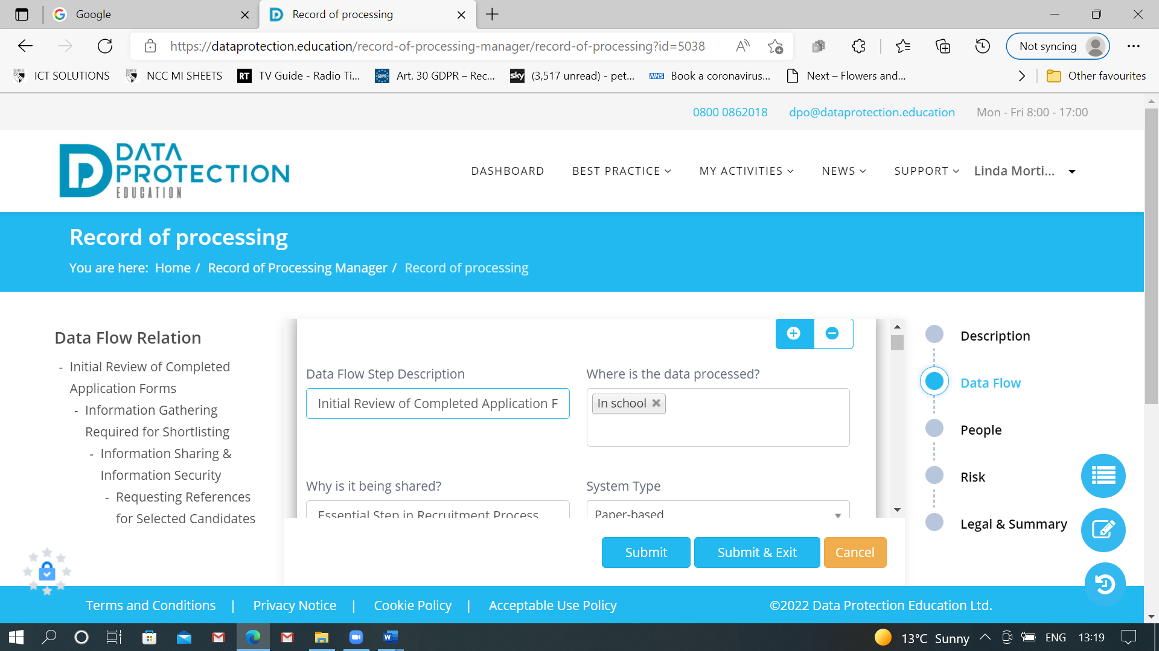

The data flow identifies the flow of data throughout the process from start to finish. The example below gives details on how you would complete this section:
Data Flow Step Description: Identify the step in the process eg step 1 Initial Review of Completed Application Form
Where is the data processed? In school
Why is the data being shared? Essential Step in Recruitment Process
System Type Is the data in hard copy paper format, or supplied electronically via email etc?
Sysem Security What are the local systems to ensure that data is saguarded, ie school works in line with operational policies and procedures, has access controls in place etc?
System Location Is the system at school level or in the Cloud?
Location of data Is the data in a hard copy document or email and are these stored on a local computer, linked to a local network?
System software What software is used when processing the data ie Microsoft Word / Excel, Office 365, Google Platform etc?
IT hardware used in this step Detail the IT hardware used when processing the data ie Headteacher’s laptop, school secretary’s PC, office PC, finance PC etc? When adding details of new hardware you can add further informatiion about the security measures applied to the hardware ie password protected, anti-virus software, malware protection, firewall, patches and updates.
Who is this informtion shared with (Third Party Organisations) For this RoP ther would be no requirement to share data with a third party orgnanisatin. However, depending on the process which is being mapped, it may involve sharing information with the organisation’s HR or Payroll provider and these are acting as a third party.
Who is this information shared with internal and individuals ? Depending on the process being mapped, note all staff who have access to the personal information ie Headteacher, School HR Manager, Senior Adminstrator etc.
Who is this informtion shared with (other)? Note here all other people who may have access to the information ie Governors, parents, volunteers etc.
Status of external organisation / vendor This relates to the third party when personal information is shared, and their designated role ie Controller / Processor / Joint Controller / Sub Processor? For example, an payroll processor will be designated as a Processor.
How is the data transported? Is the data sent electronically via email, uploaded to a secure portal, sent via external mail etc.
Security when moving data Note here the safeguards that are in place ie physical security, emails are encrypted, access rights to secure portals to upload data.
Additional information This is a free text box, where the Data Controller can outline the processs or add relevant information relating to their local systems.

TAB 3 - PEOPLE
In this example the School HR Manager is selected as the Business Process Owner and the Headteacher has an Executive Role. This might be different for your school and you can add additional boxes as required:
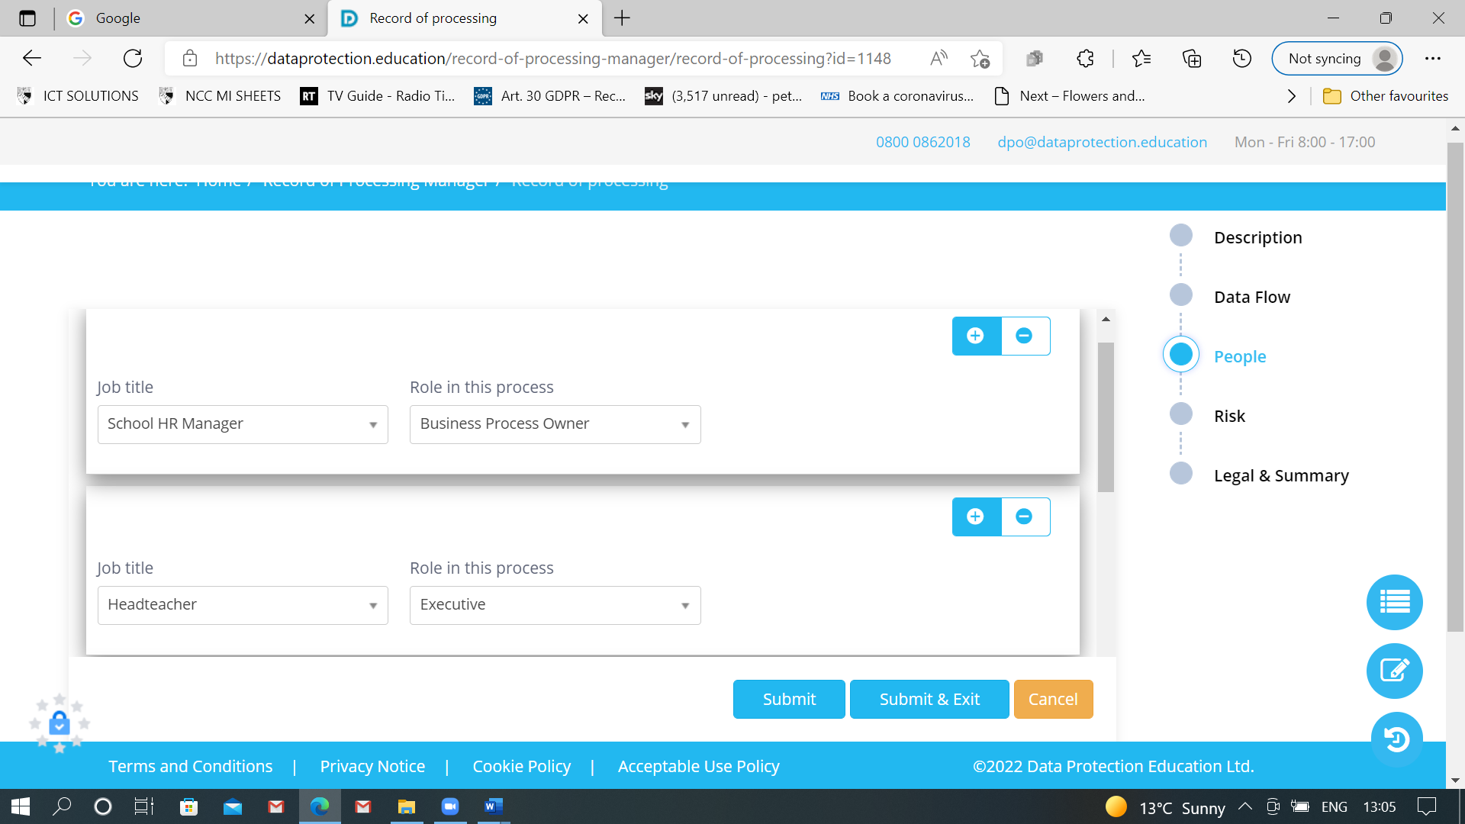

TAB 4 - RISKS
Risks associated with: INITIAL REVIEW AND PROCESSING OF THE APPLICATION FORM
We will now look at the risks associated with the first step of this process and define what mitigating factors we have in place to ensure the data is secure, only used for a specific purpose and that there are policies and procedures in place that underpin the security of the data.
This example will look at the first risk from the data flow:
Initial review of the Application Form - shortlisting will involve collating and making hard copies of all relevant documents for the shortlisting panel
Type of Risk: Inadequate Controls
Likelihood of Risk: Possible
Level of DS Identification Significant
Potential Impacts:
Risk of ID fraud / ID theft if there are inadequate controls to safeguard the data subjects personal
information contained within the application form, CV eg; NI number, contact details, employment
history, qualifications, DfE teacher reference number, disability information, ethnicity, education etc.

Further risks if the data subject’s covering letter/CV are left accessible as likelihood of more personal information easily available eg their home address could be exposed leading to a risk of actual physical harm to the data subject.
If ID fraud / ID theft occurs this could lead to litigation brought against the school via employment tribunal – with associated costs to defend.
Should fraud occur this could carry a reputational risk to the school resulting in a decline in student enrolment, leading to impact on longer term financial impact and affeting staff morale.
Details of Mitigation: Treat by
School has defined roles and responsibilities in management of the recruitment process.
Procedural handbooks are in place and school uses checklists relating to the necessary processes.
Clear Desk and Clear Screen policy observed at all times with regular GDPR audit walks taking place to raise staff awareness
Hard copies of prime documents retained securely at all times with strict controls (key management in place)
Staff training & awareness of the GDPR.

TAB 5 – Legal and Summary
This tab would include everything from legal basis to data retention and DPE complete this for you.

Core data guide

Hardware

Organisation | Software/OS | Hardware type | Deployment year | Hardware security measure
School name | Windows 10 | Laptop
School name | Windows 10 | Desktop
School name | Windows 10 | Server

Software

Organisation | Supplied by (organisation/vendor) | Name | Version | Software security measures
School name |  | ParentMail

Third Parties (Venders)
Capita - SIMS
Google
Microsoft

